SIMATS ENGINEERING
ASSESSMENT TOOL 1

COURSE NAME: Database Management Systems
COURSE CODE: CSA05

COURSE OUTCOME COVERED
CO2: Apply the relational model, relational algebra, SQL query structures, and views
to solve database querying and data manipulation problems. (BL3, BL6)
Activity Tool : Analytical Problem Solving (High)
Assessment Tool Weightage: 35%

QUESTIONS Total Marks: 50
Q.No Question Level Marks

1 Apply relational algebra operations (σ, π, ∪, -, ×, ⋈) on the given Employee and Department relations to retrieve required records.
ANSWER:
Apply Relational Algebra Operations (σ, π, ∪, −, ×, ⋈)
Assume:
EMPLOYEE(EmpID, EmpName, DeptID, Salary)
DEPARTMENT(DeptID, DeptName)
a) Selection (σ)
Employees whose salary is greater than 50000.
$$σ_{Salary>50000}\left(EMPLOYEE\right)$$b) Projection (π)
Display only employee names.
$$π_{EmpName}\left(EMPLOYEE\right)$$

c) Union (∪)
Assume:
EMPLOYEE2024(EmpID, EmpName)
EMPLOYEE2025(EmpID, EmpName)
Employees from both years.
$$EMPLOYEE2024∪EMPLOYEE2025$$d) Set Difference (−)
Employees in 2024 but not in 2025.
$$EMPLOYEE2024-EMPLOYEE2025$$

e) Cartesian Product (×)
$$EMPLOYEE×DEPARTMENT$$

f) Join (⋈)
Employee details with department name.
$$EMPLOYEE⋈_{EMPLOYEE.DeptID=DEPARTMENT.DeptID}DEPARTMENT$$
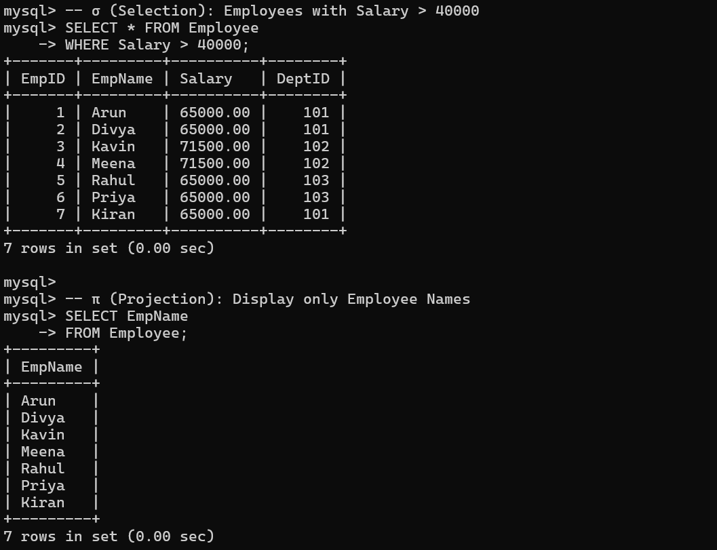
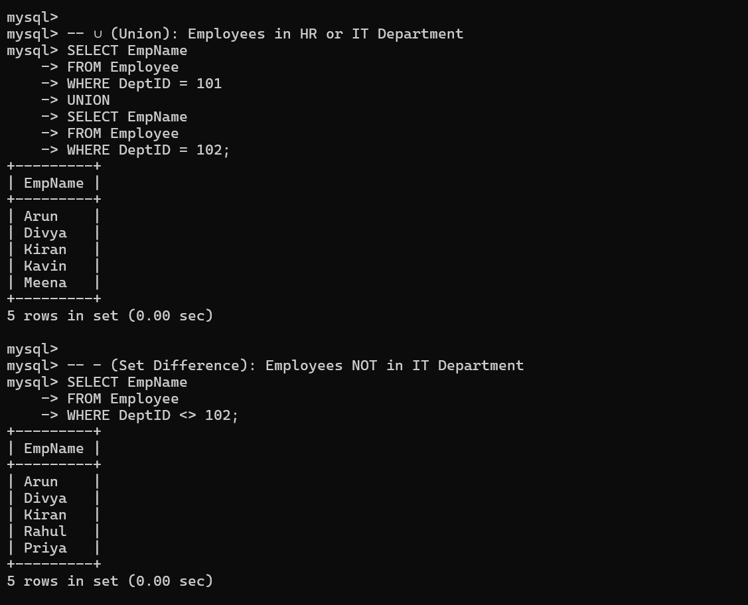
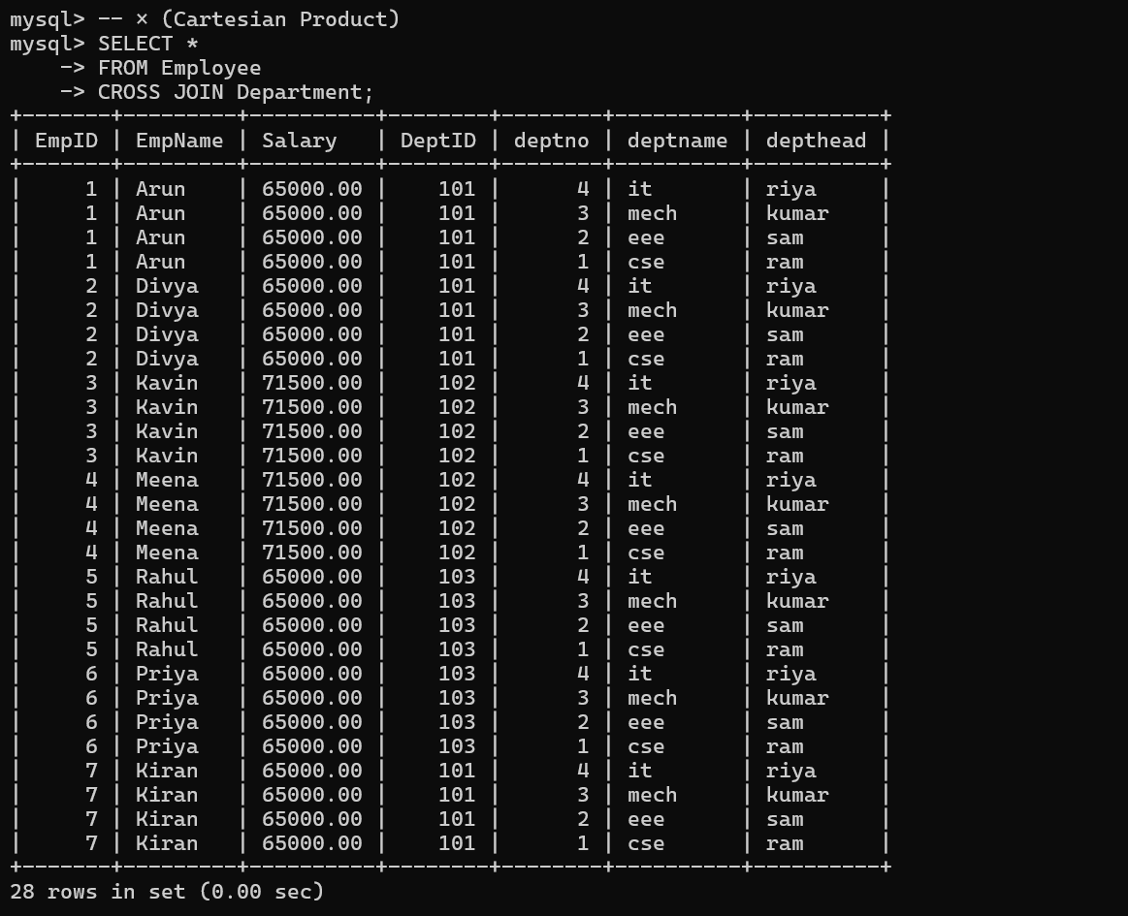
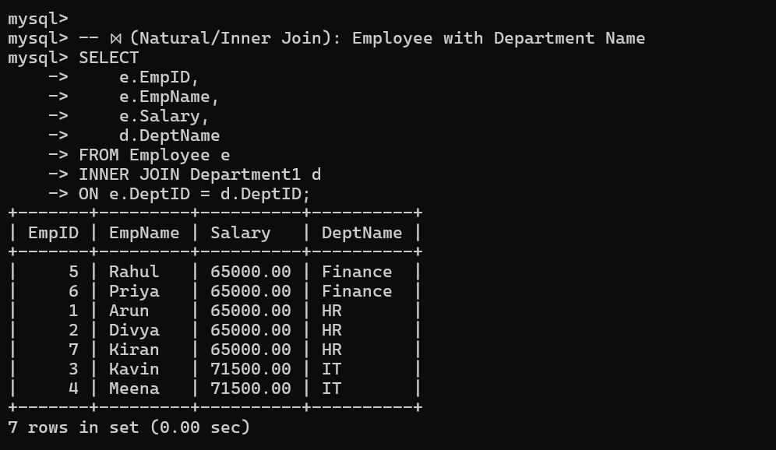

2 Write SQL DDL statements to create STUDENT(SID, Name, DOB, DeptID) and DEPARTMENT(DeptID, DeptName) tables with all appropriate constraints.
ANSWER:
CREATE TABLE DEPARTMENT1
(
DeptID INT PRIMARY KEY,
DeptName VARCHAR(50) NOT NULL UNIQUE
);

CREATE TABLE STUDENT
(
SID INT PRIMARY KEY,
Name VARCHAR(50) NOT NULL,
DOB DATE NOT NULL,
DeptID INT,
FOREIGN KEY (DeptID)
REFERENCES DEPARTMENT(DeptID)
ON DELETE CASCADE
ON UPDATE CASCADE
);
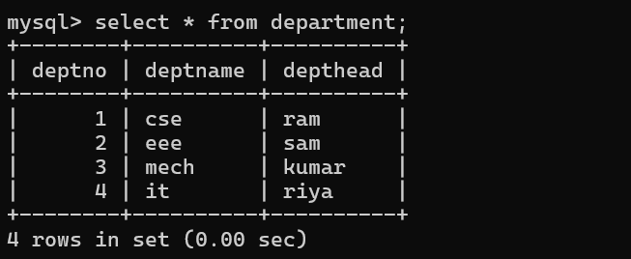
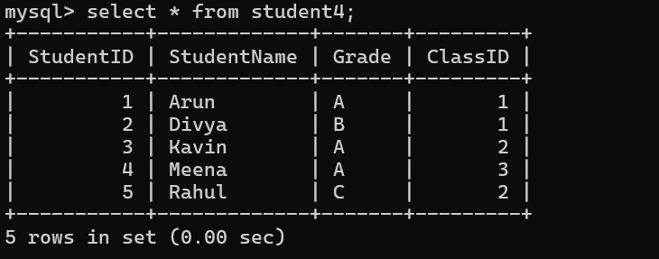

3 Formulate SQL queries using GROUP BY, HAVING, and aggregate functions (COUNT, SUM, AVG, MAX, MIN) on a given Sales dataset.
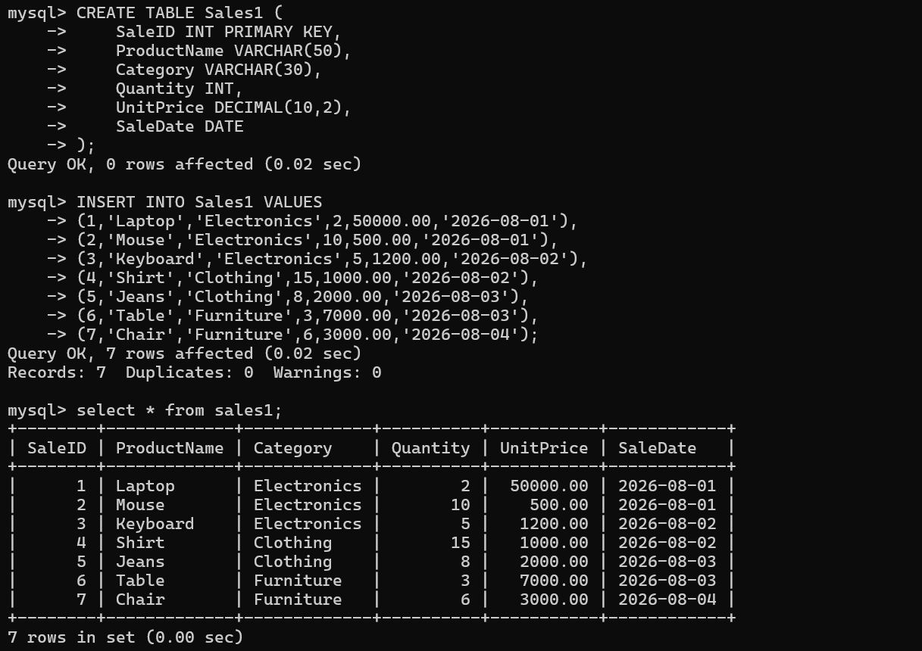
4 Write a correlated sub-query to find employees earning more than the average salary of their own department.
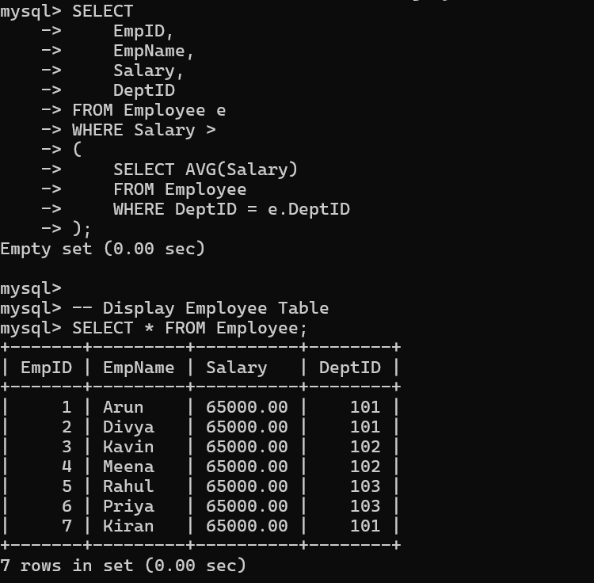
5 Apply all types of JOIN operations (INNER, LEFT OUTER, RIGHT OUTER, FULL OUTER, CROSS) on Employee and Project tables.
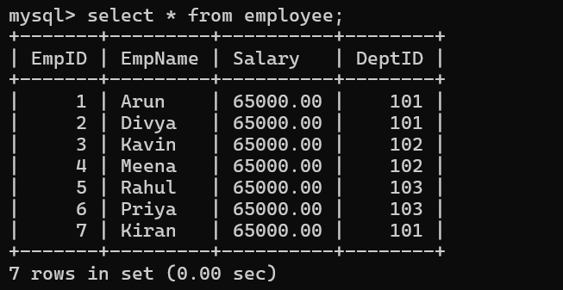
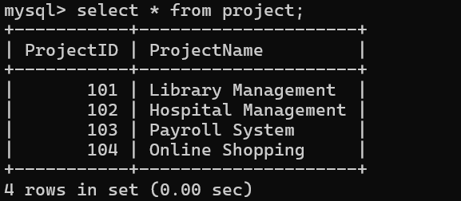
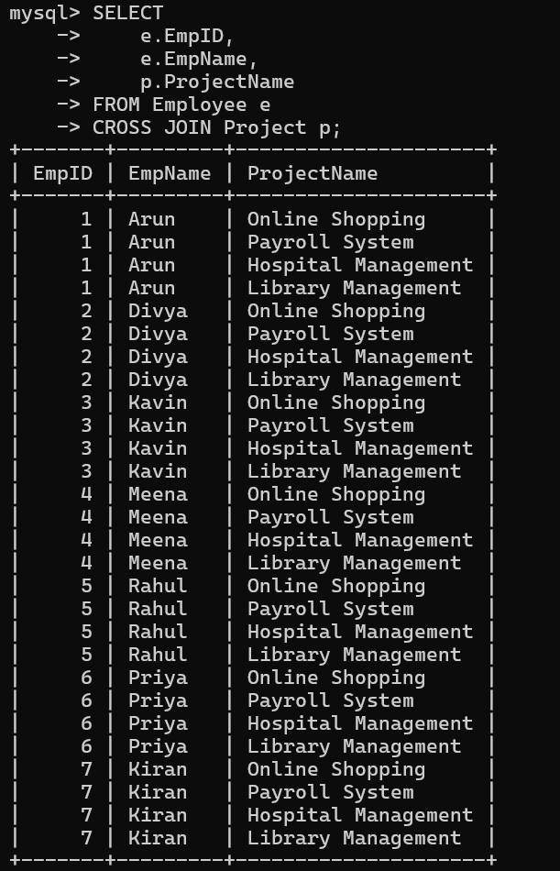
6 Create a view ‘DeptSalaryView’ that displays department name, total employees, and average salary. Write a query on this view.
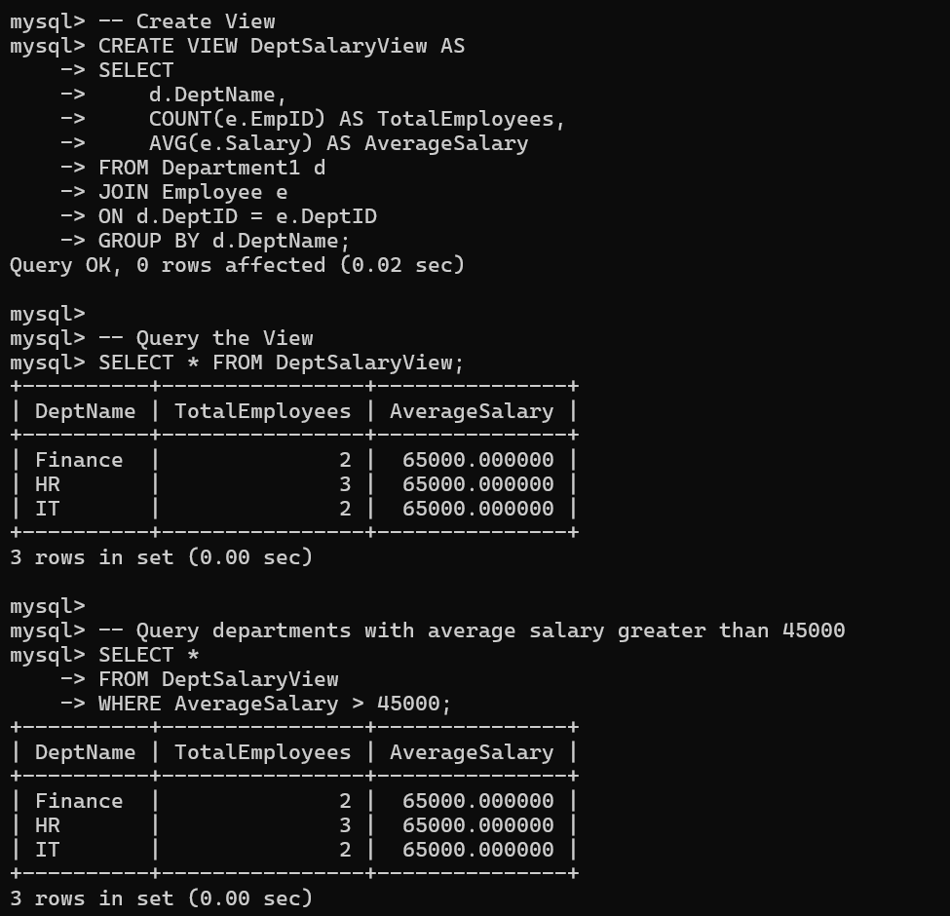
7 Construct a relational algebra expression for the following: Find names of students who are enrolled in all courses offered.
ANSWER:
Relational Algebra
Relations:
STUDENT(SID, Name)
COURSE(CID)
ENROLL(SID, CID)
Students enrolled in all courses.
Using Division:
$$π_{SID}\left(ENROLL÷π_{CID}\left(COURSE\right)\right)$$
To display names:
$$π_{Name}\left(STUDENT⋈\left(π_{SID}\left(ENROLL÷π_{CID}\left(COURSE\right)\right)\right)\right)$$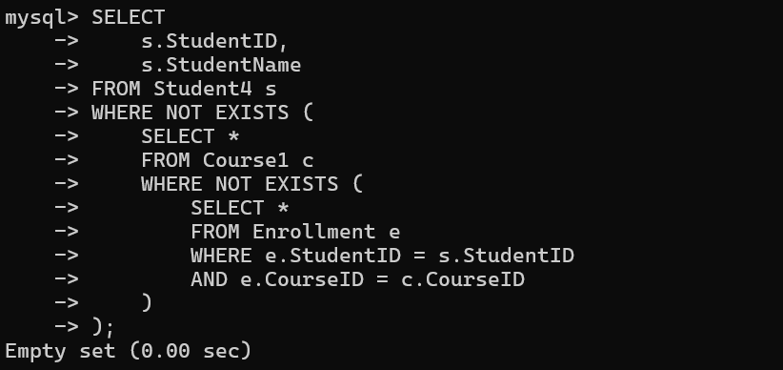
8 Write SQL DML statements (INSERT, UPDATE, DELETE) with integrity constraint enforcement for a given scenario.
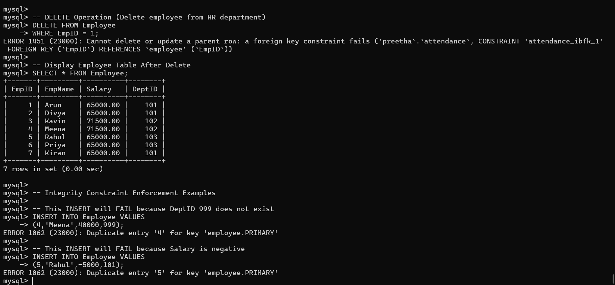

9 Apply tuple relational calculus to express a query: Find all employees who work in the ‘IT’department and earn more than 50000.
ANSWER:
Tuple Relational Calculus
Find employees working in the IT department and earning more than 50000.
$$\left\{ t∣EMPLOYEE\left(t\right)∧t.DeptID=d.DeptID∧DEPARTMENT\left(d\right)∧d.DeptName=^{'}IT^{'}∧t.Salary>50000 \right\}$$

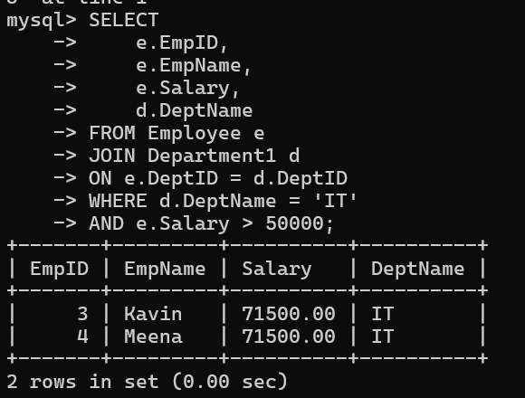
10 Design a relational schema for an Airline Reservation System and write 5 SQL queries demonstrating joins, sub-queries, and views.
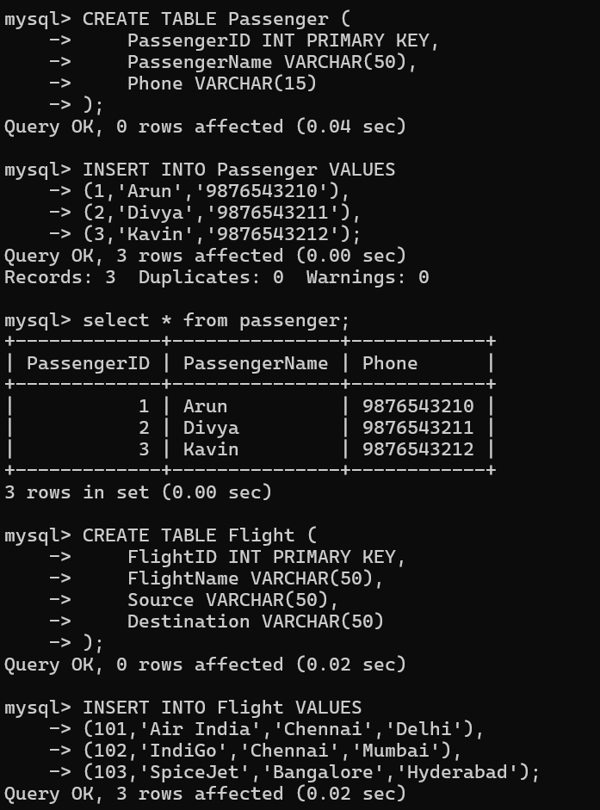
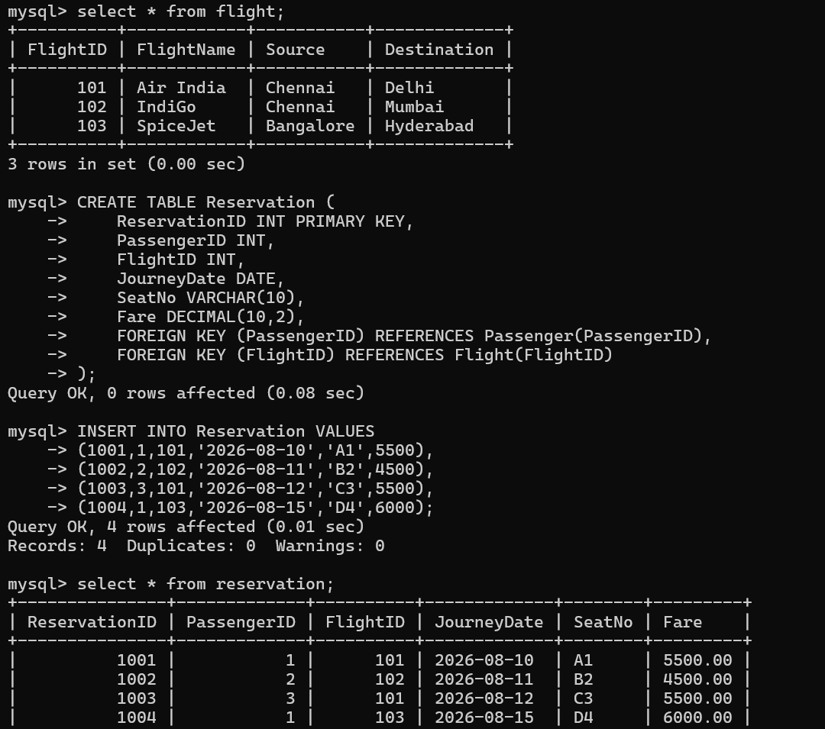
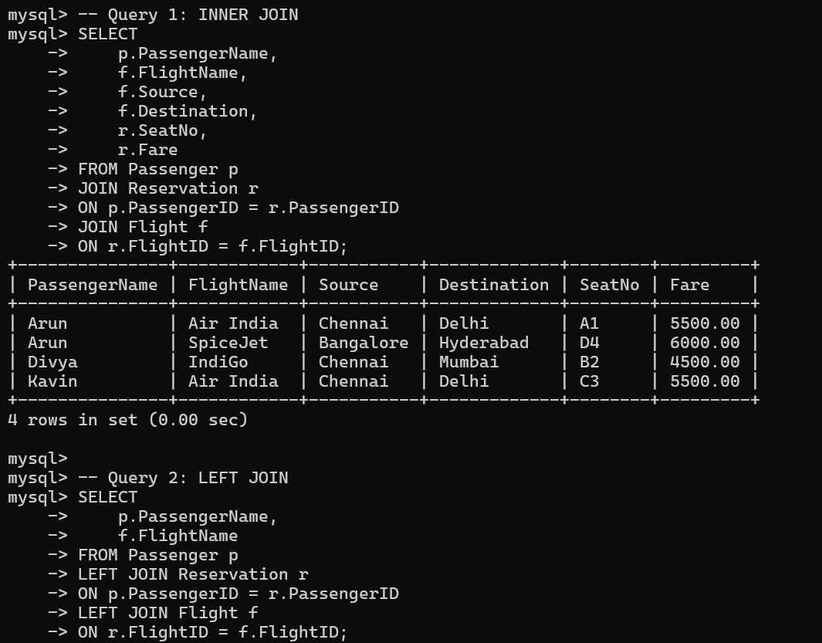
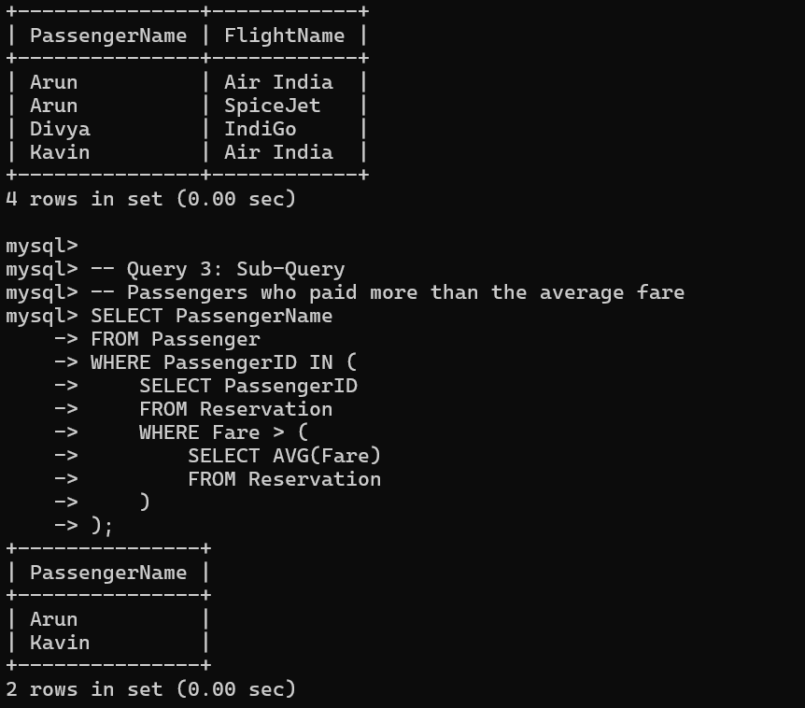
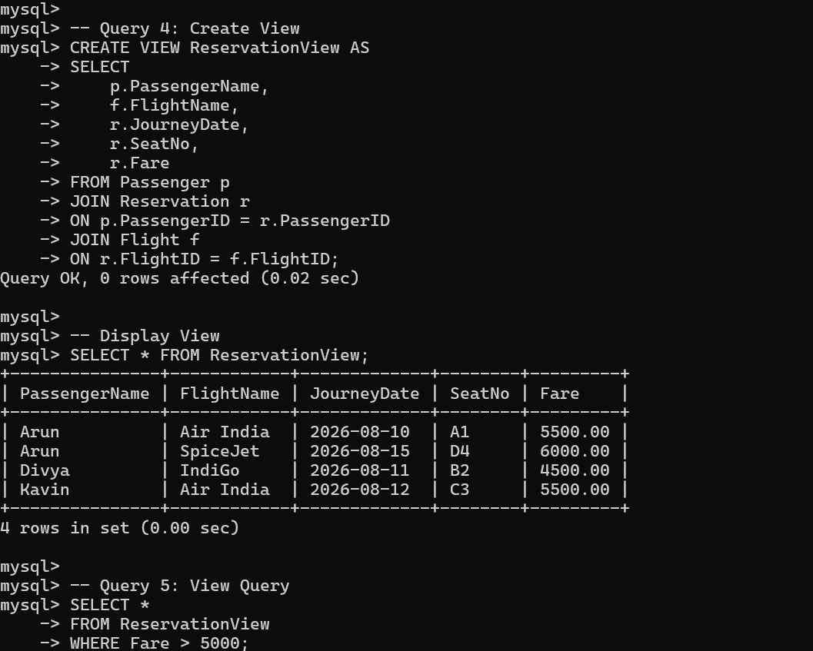
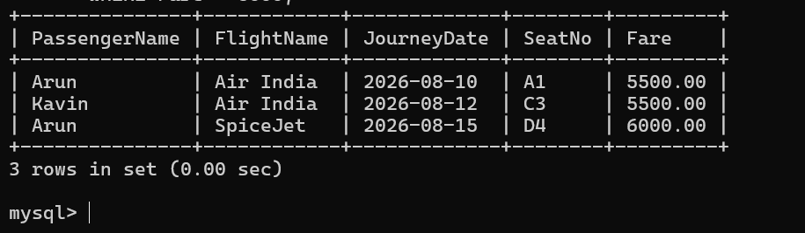

Code of Conduct:
I _M.V.PREETHASHRI(192524476)__ (Name / Reg No) certify that this submission is my
original work and that I have adhered to the guidelines specified for this assessment.
I understand that any violation of academic integrity rules will result in disciplinary
action.
Signature of the student: M.V.PREETHASHRI

